Scythian ‘Phyrigian’ Hat

For the StormMaker Master and Apprentice challenge I decided to make a Scythian hat in the Phyrigian style. I was fortunate in that my Master Baroness Achaxe had already recorded a series of videos of the wet felting process last summer(Achaxe Auchata Felting Tutorials) . The nature of this competition was to virtually engage in the making process between Master and Apprentice. Utilizing the videos as my primary source of instruction seemed a great way to honor the spirit of the competition.
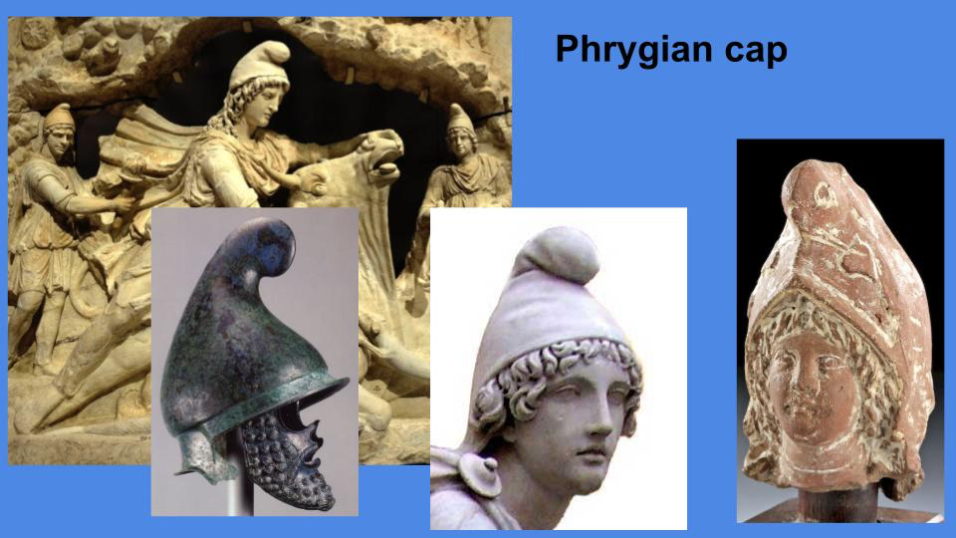
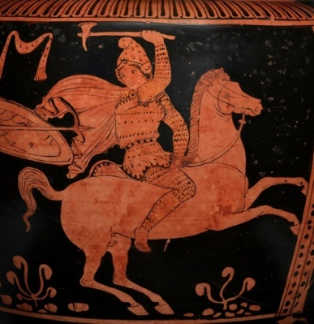
‘Scythian’ research is blessed with a wealth of preserved items but a lack of context exacerbated by their lack of the written word. Not only did the lands of ‘Scythia’ compose of different cultures and tribes but the expanse of their territory stretched and interacted with many other ancient civilizations. Thankfully, their contemporaries in Greece were prolific writers and artists and Scythians featured prominently in their black-figure pottery. In these artifacts we are treated to the menagerie that is Scythian hats. One of the more iconic styles is the ‘Phyrigian’ cap with its prominent curving dongle on top. Outlandish by modern standards it was ubiquitous of the time and widely used by many of the cultures that interacted with the scythians. It was this style that I chose to replicate with my work.
Figure 1 'Amazonian'
One of the challenges of this competition was to use materials that were already on hand. I took this to heart and favored available material over period material that would need to be purchased. Over the course of the project, I had to borrow two tools both loaned to me by Achaxe: a carding machine and punch/plier for attaching the metal pieces. I purchased a reed mat for rolling as well as Dr Bronners Peppermint soap knowing that this would not be the last time wet felting is done in my household. I already had a box of raw wool given to me last fall as well as large collection of red wool that would be used as the band. As I did not posses any of the needed materials to dye the fabric I opted for a natural base for the hat and used the available red wool. I used modern thread that was already owned and matched the colors as best I was able. All the metal working pieces including the material was already owned. Except for the test piece that was made from copper the metal is all brass. Scythian plaques were typically gold, or gold foiled. Bronze was readily available in period and often used but I did not have any suitable for the project. Brass was used for its similar visual and material properties.
The construction of the hat was done over the course of a roughly a week. The initial carding of the wool was done weeks before the construction began in earnest.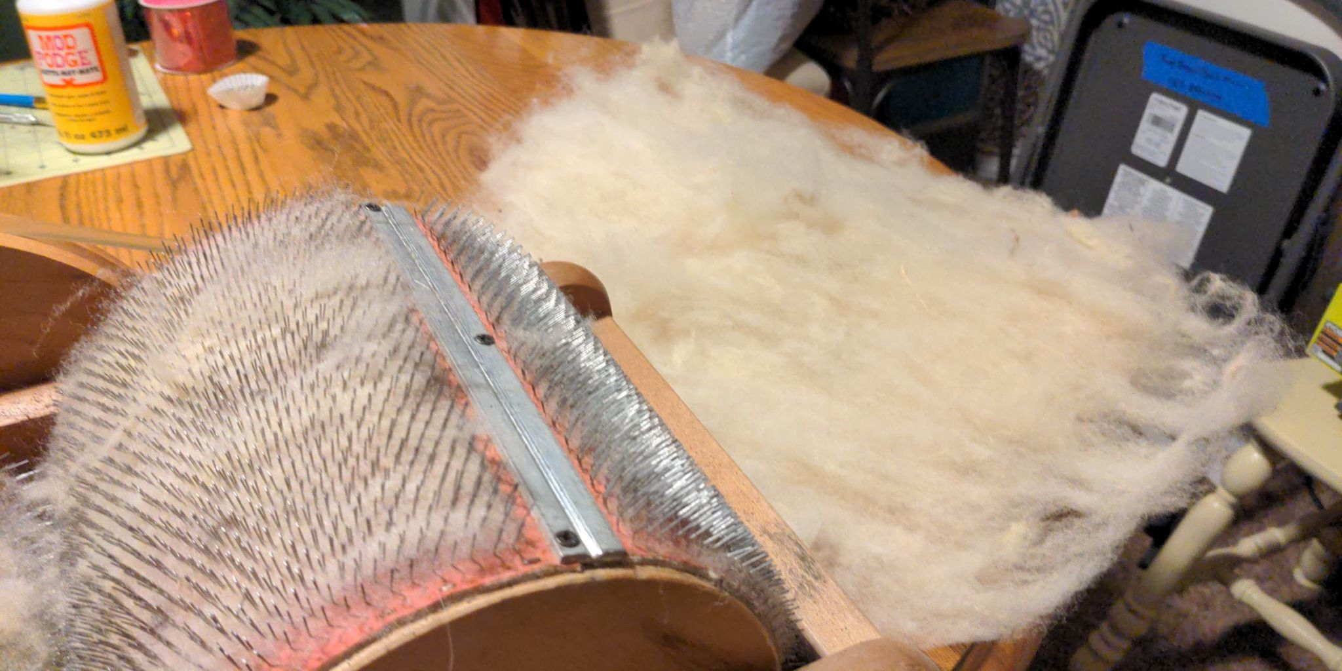 This was the first time I was able to use the videos for reference as Achaxe also started with raw wool and carded it. This is where I made one of my first mistakes. I did not watch ahead in the process or if I did, I did not retain what the next step would be. I thought for this process I needed as solid of a sheet of carded wool as I could get. I carded two pieces, then ran the pieces together forming a very dense piece. I also had help doing this process, my wife Kata loves wool and felting and was eager to try her hand at carding. She produced 30-40% of the carded wool. Overall, I ended up with roughly a dozen double-carded pieces and half a dozen single felted pieces. I have one leftover piece of one-ply felt. 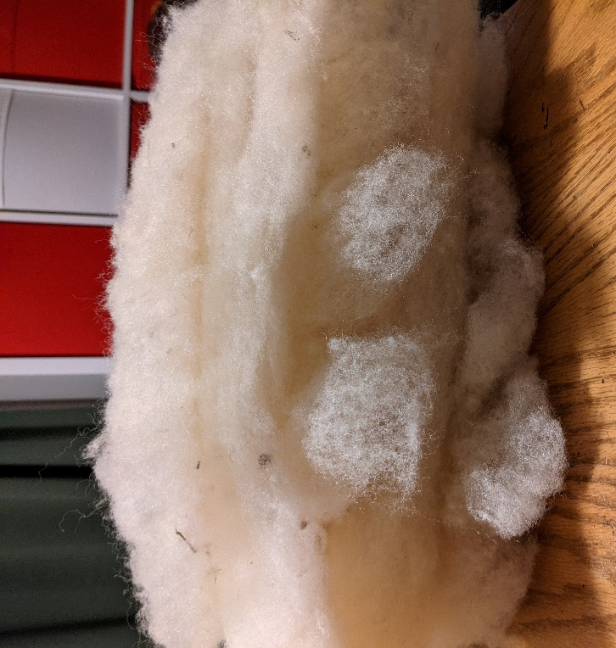
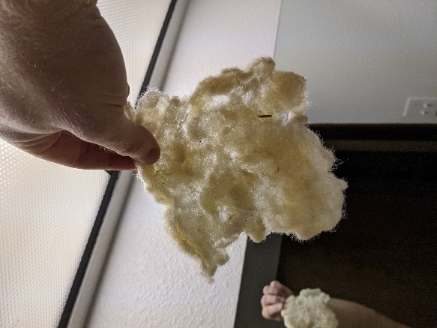
After carding I did a test patch of felt to get an idea of the shrinkage rate. It was planned as a 4”x4” section. The test was a failure. I was not gentle enough and the actions spread and thinned the fabric rather than felted it. My test piece ended up vaguely 5”x6”. I went back and carefully watched the test patch video. It was at this point that I watched the entire process. I then watched the test patch video again while doing my next test piece. I used per the video’s instructions hot water (120 degrees is what it comes out of the tap) and generously used Dr Bronner’s peppermint soap. I placed the test piece in a Pyrex pan on top of a measured cutting mat. This allowed me to see the changes in size easier. I laid the felt running vertically, horizontally, vertically at 6” wide and 6” long. This proved important as the piece shrunk more on the horizontal than the vertical. With the video and sending images over Facebook messenger to Achaxe about the progress I was able to produce a hard felted test piece that shrank 1.5” on the vertical and 2” on the horizontal.
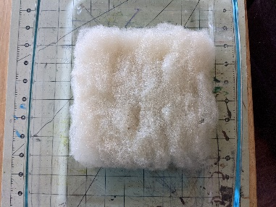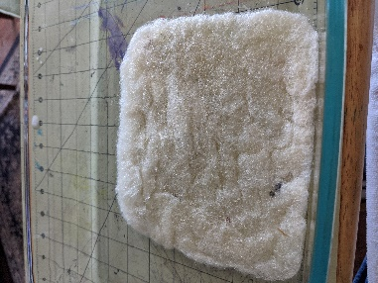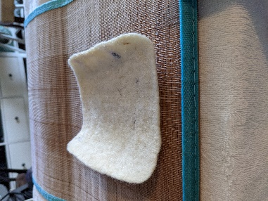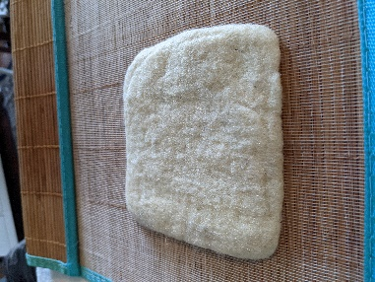

Armed with that knowledge I started the main wet felting process a week later. I did not rewatch the videos before starting and that was a mistake. Having ready access to prerecorded process was a huge benefit and had I taken advantage of that would have prevented me from making variations that ultimately made the project harder and at greater risk of failure. I made the decision to not pull the felt apart and lay it down but rather lay the entire sheets down and overlap them. I did a single layer horizontally and a single layer vertically. In some instances, I supporter thinner areas with one-ply sheets. running the same direction. I thought the nature of them being carded would make it easier to felt, I was also hoping it would make it quicker soft felt.
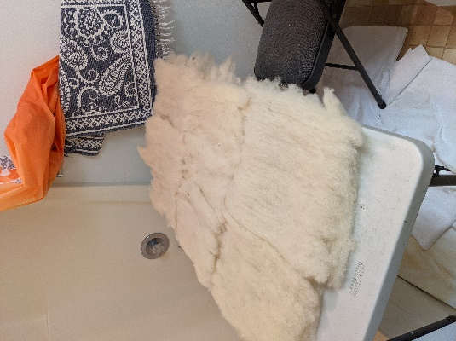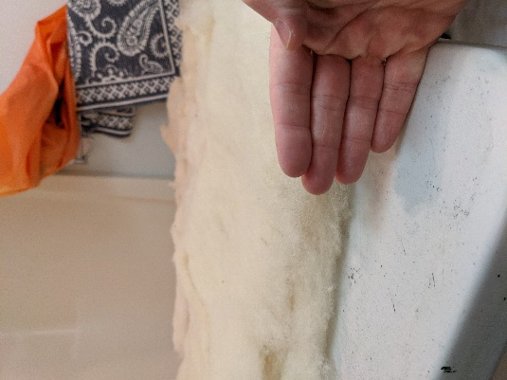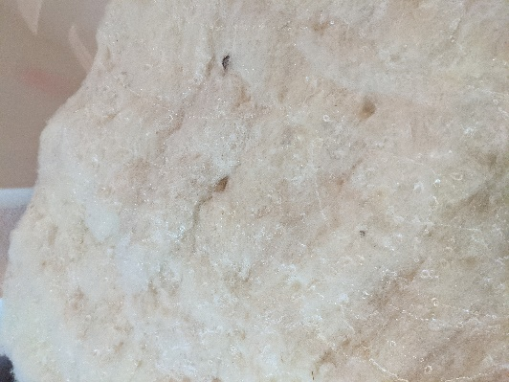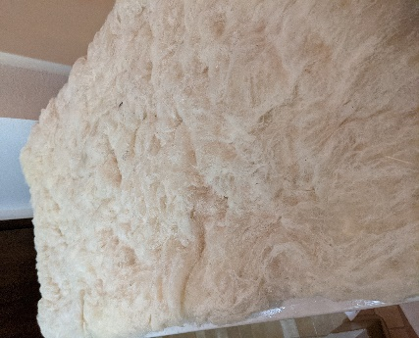
After approximately 3 hours of felting, I stopped for the evening. In some areas the texture seemed right, it was soft felted or nearly there by my uneducated estimation. However, it had several ridges and overlaps forming. I had not experienced these in my test felting process and was not sure how to proceed. Given the size of the piece I also had not been able to control my edges well, some were folded over and thick, some were thin and still in need felting. Felting is a very tactile process that is hard to convey in photos. After exchanging a few images Achaxe asked for a video chat. I showed her how it moved when lifted, scratched at the surface, pulled out fibers and showed what the under side looked like. Her tone of voice, thoughtful noises, and questions she asked told me all I needed to know before it was said: the prognosis was bleak.
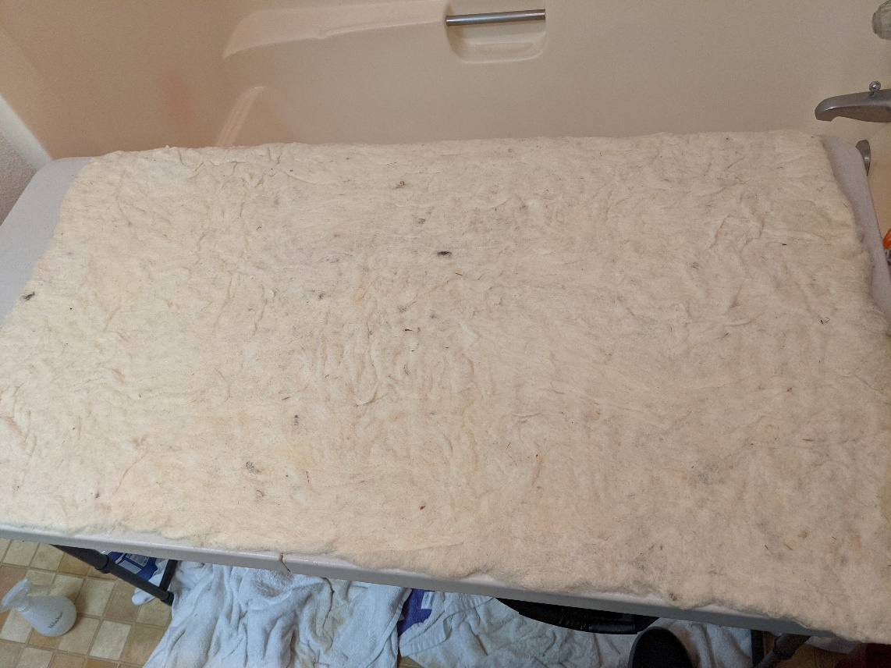
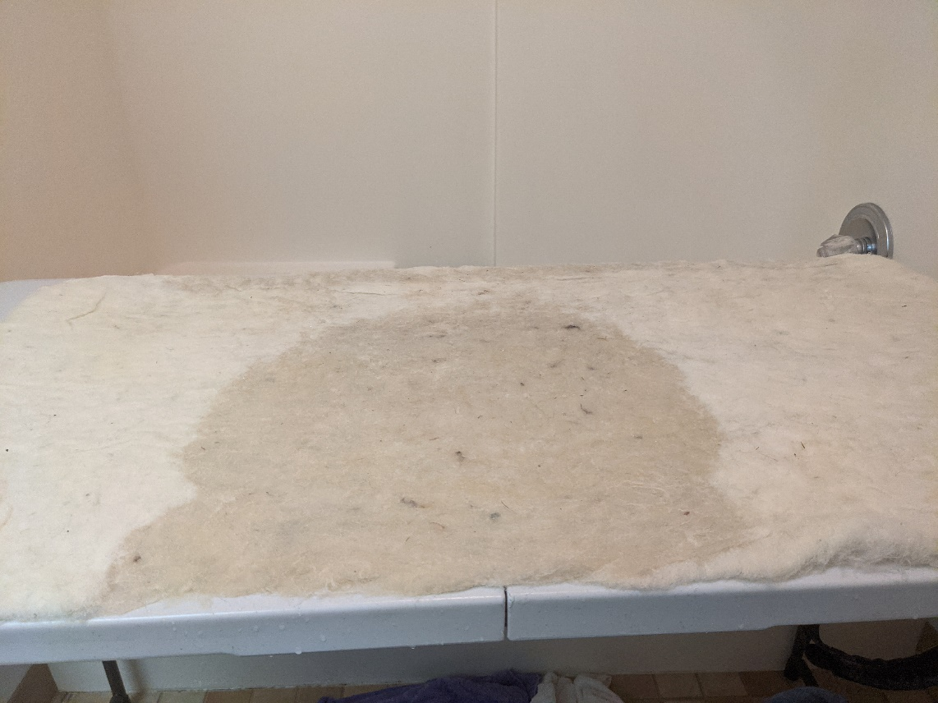
The ridges and lumps were large and weakened the entire structure. They were also numerous so even working around them was going to be difficult. At this point the project was likely a failure. I should continue to work it and hopefully get it to the hard felting stage regardless. Failure is always an option and I could still submit a failed piece for the competition with a postmortem. Achaxe and my wife Kata advised I did have option to increase my chances of success. Needle felting. The practice is not known in period, but I did have all the supplies on hand. By needle felting down some of the larger ridges I was able to strength the integrity of the piece. I did 4 of the larger more concerning overlaps.
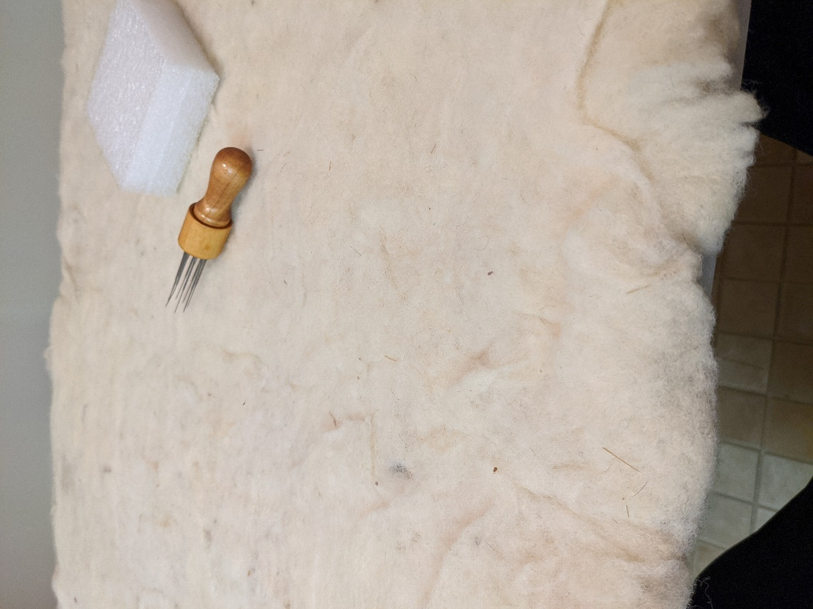
After that I kept going on the process moving the piece to the soft felting stage and after a few more hours into the hard felting stage. Wet felting works with heat and moisture opening ridges on the hairs to interlock with each other. Its best done in a hot steamy location. I did it in a bathroom in February. The piece would not fit in my bathtub, so I had the table half in, half out and the shower curtain over me to try and trap as much heat and moisture as possible. Working the large reed mat, a table, and myself in a tiny bathroom was not an easy task but at this stage all agitation was good agitation for the wool. 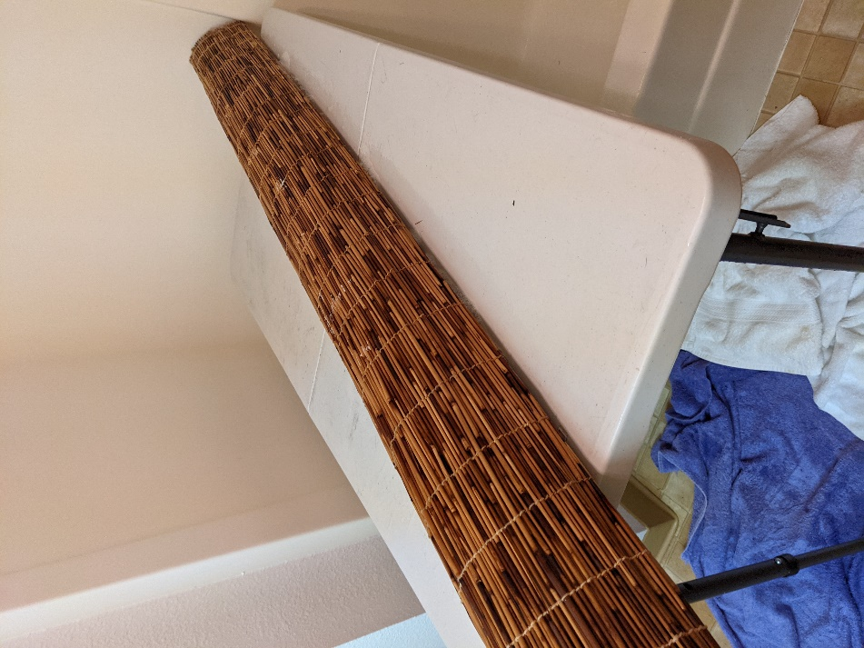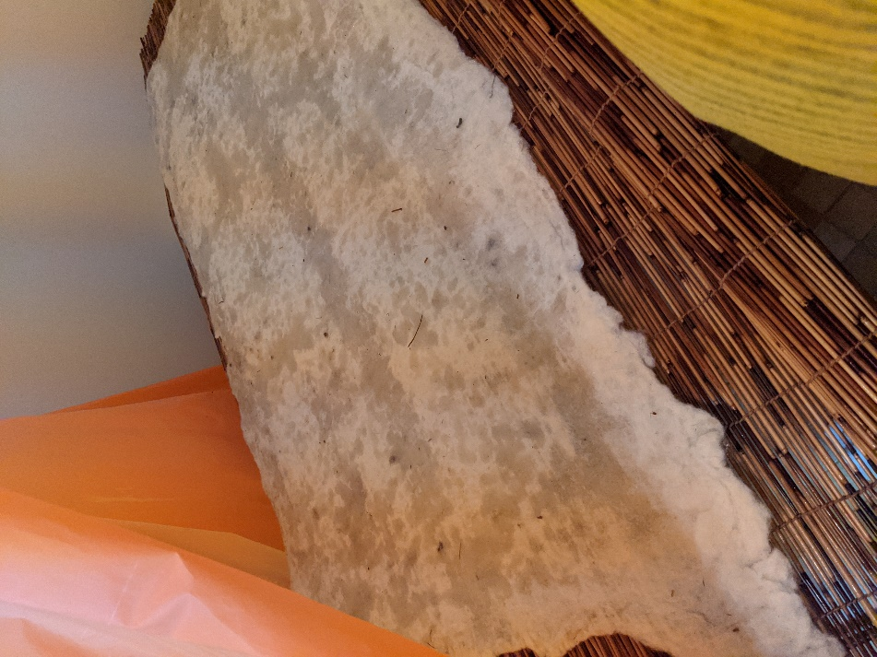
It was a success, I had created a pebbly texture that did not slide across itself. There were few lumps and almost no thin spots. I let it dry overnight and did a socially distant, double masked drop off of the wool to get confirmation it was ready. That could have been done over video but I also needed to pick up the metal punch so it was an opportune time.
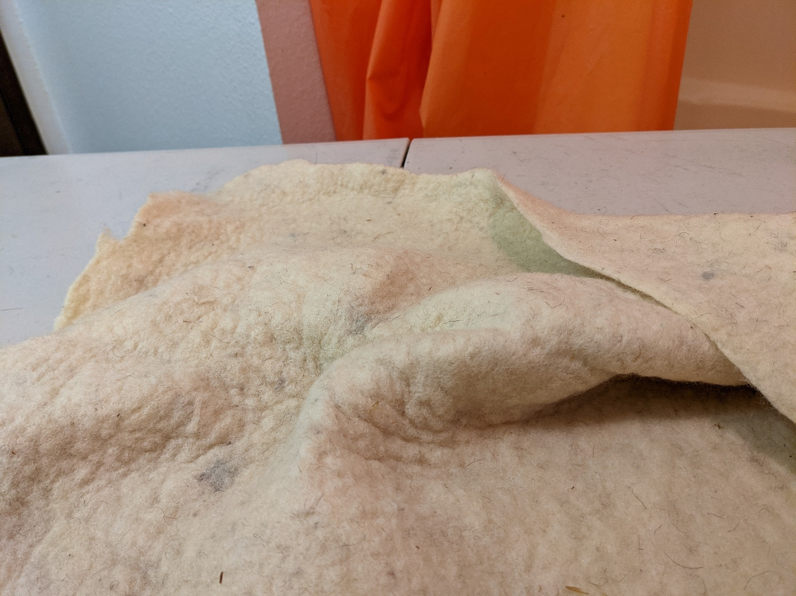
The rest of the process went quickly. I had been given Phrygian wool hat after I started the project as a gift by Achaxe. This would become the model I was attempted to replicate. I am a visual person so I made posterboard cutouts of the hat used red acrylic felt to simulate the band and paper cut outs of the repousse pieces I was going to do. I drew inspiration for the design and layout of the pieces from a modern interpretation. I think the design is entirely plausible, within the typical stylizing of Scythian art and utilizing their well-known colors of white and red.
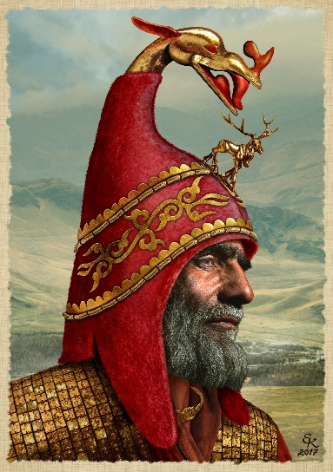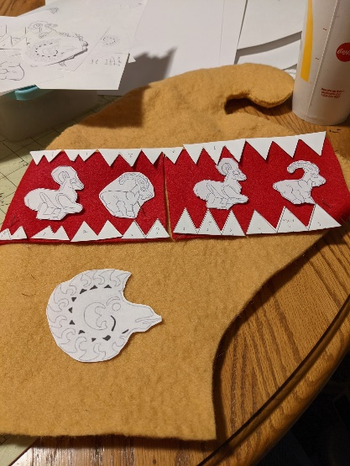

Before the wet felting process began, I started on some of the metal work. Repousse is a new passion of mine and I wanted to push myself with this project. All told the plan was for nearly 60 pieces. I used thin 34-gauge foil pieces and a center punch to create the triangle teeth. 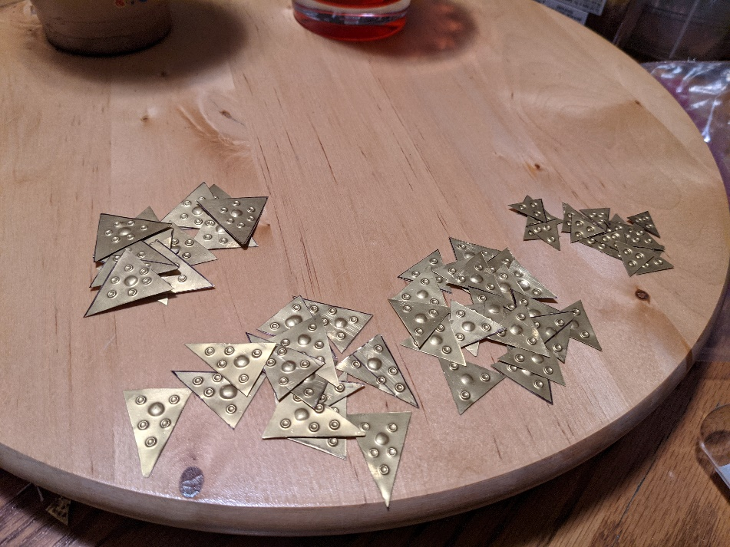 I had originally intended for 8 26-gauge repousse pieces on the hat. Scythians were not shy about using metal working on their clothing. I had also intended to produce 2 pierce work pieces but did not have the tools needed so they were left off in the spirit of the challenge. The copper test piece was the 3rd repousse piece I have ever done. It was the first successful one, every other piece had had major punch throughs. 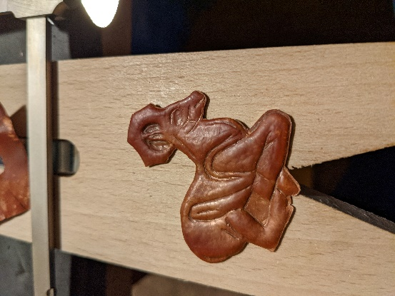 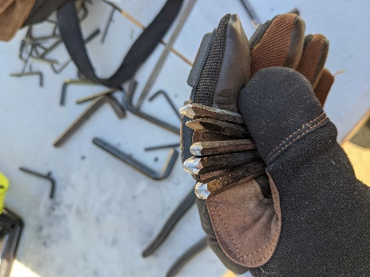 The 4 rams done in brass are items 4-7 that I have ever created. All but one of the repousse punches used were hand made by myself, also a first for me.

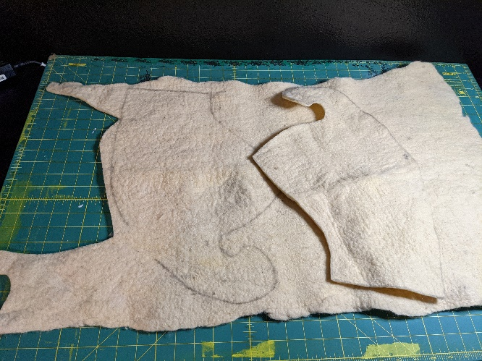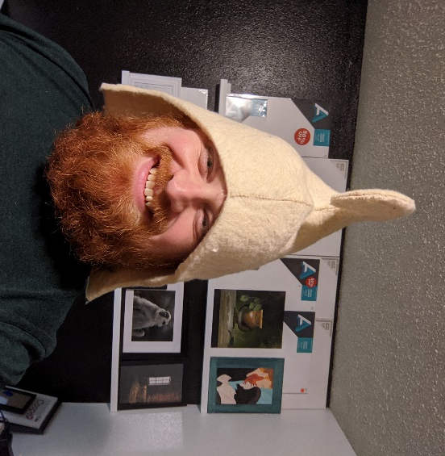
I cut out and stitched together the cap from the felted sheet. After initially trying a saddle stich I changed to the baseball stich at recommendation from Achaxe. I whip stitched the red band down and carefully stitched all 56 pieces of metal to the hat.

Failure is always an option but thankfully was not the outcome for this project. Given this is the first thing I have ever wet felted, 3-8th piece of repousse I have ever made, and second time I have done hand stitching I am exceptionally pleased with the result. Setting out to use the recorded videos primarily as my source of instruction was a challenge. It meant that the ownness was on me for catching my mistake or showing the process at critically important times. This greatly increased the margin for error. It also showed how truly successful the video series was. Every mistake I made could have been fixed by watching that section of video again right before or during the attempt.
This project is not complete. It is my personal belief that outside of gifts or burials no piece of Scythian garb is every truly complete. I feel that they may have constantly upgraded and added to their pieces. Wealth was meant to be shown off. To that end I am excited to keep adding to this hat. Maybe one day even upgrading to true Scythian Gold.

